Name: Anirban Saha Anik

ID: 18-36207-1, Section: E

**Data Communication Lab Assessment 3**

My ID related calculation:

AB-CDEFG-H

18- 3 6 2 0 7 -1 (my ID)

A = 1; B = 8; C = 3; D = 6; E = 2; F = 0; G = 7; H = 1.

Here, 8-bit ASCII characters:

E = 2 = 00110010;

F = 0 = 00110010;

G = 7 = 00110111;

In together bit stream of 24 bits:

00110010 00110010 00110111

Here,

G = 7 Hz;

G+2 = 9 Hz;

G+4 = 11 Hz;

G+6 = 13 Hz;

G+8 = 15 Hz;

G+10 =17 Hz;

G+12 = 19 Hz;

G+14 =21 Hz;

Answer to the question no 1:

x=[0 0 1 1 0 0 1 0 0 0 1 1 0 0 0 0 0 0 1 1 0 1 1 1];

n=length(x);

i=1;

while i<n+1

t=(i-1)/3:1/5000:(i+2)/3;

if (x(i)== 0 && x(i+1) == 0)

ask=1*sin(2*pi*1*t);%H=1

elseif (x(i)== 0 && x(i+1) == 1)

ask=2*sin(2*pi*1*t);%H=1

elseif (x(i)== 1 && x(i+1) == 0)

ask=3*sin(2*pi*1*t);%H=1

elseif (x(i)== 1 && x(i+1) == 1)

ask=4*sin(2*pi*1*t);%H=1

end

plot(t,ask);

hold on;

grid on;

title('Quadrature Amplitude Shift Key (QASK)');

i=i+2;

end

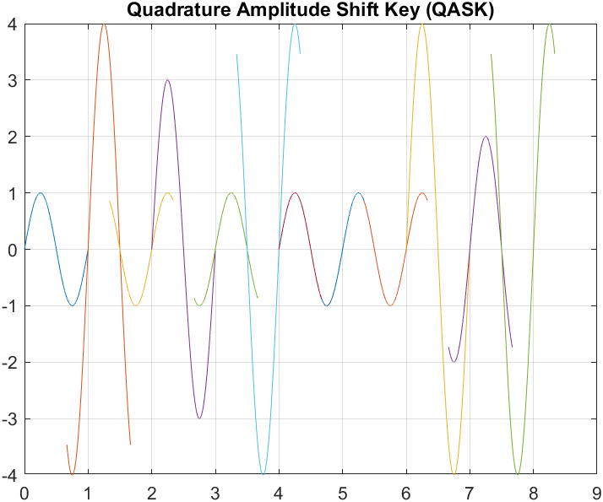

Answer to the question no 2:

x=[0 0 1 1 0 0 1 0 0 0 1 1 0 0 0 0 0 0 1 1 0 1 1 1];

n=length(x);

i=1;

while i<n+1

t=(i-1)/3:1/5000:(i+2)/3;

if (x(i)== 0 && x(i+1) == 0 && x(i+2) == 0)

fsk=1*sin(2*pi*7*t);%G = 7

elseif (x(i)== 0 && x(i+1) == 0 && x(i+2) == 1)

fsk=1*sin(2*pi*9*t);%G+2 = 9

elseif (x(i)== 0 && x(i+1) == 1 && x(i+2) == 0)

fsk=1*sin(2*pi*11*t);%G+4 = 11

elseif (x(i)== 0 && x(i+1) == 1 && x(i+2) == 1)

fsk=1*sin(2*pi*13*t);%G+6 = 13

elseif (x(i)== 1 && x(i+1) == 0 && x(i+2) == 0)

fsk=1*sin(2*pi*15*t);%G+8 = 15

elseif (x(i)== 1 && x(i+1) == 0 && x(i+2) == 1)

fsk=1*sin(2*pi*17*t);%G+10 = 17

elseif (x(i)== 1 && x(i+1) == 1 && x(i+2) == 0)

fsk=1*sin(2*pi*19*t);%G+12 = 19

elseif (x(i)== 1 && x(i+1) == 1 && x(i+2) == 1)

fsk=1*sin(2*pi*21*t);%G+14 = 21

end

plot(t,fsk);

hold on;

grid on;

title('8-FSK');

i=i+3;

end

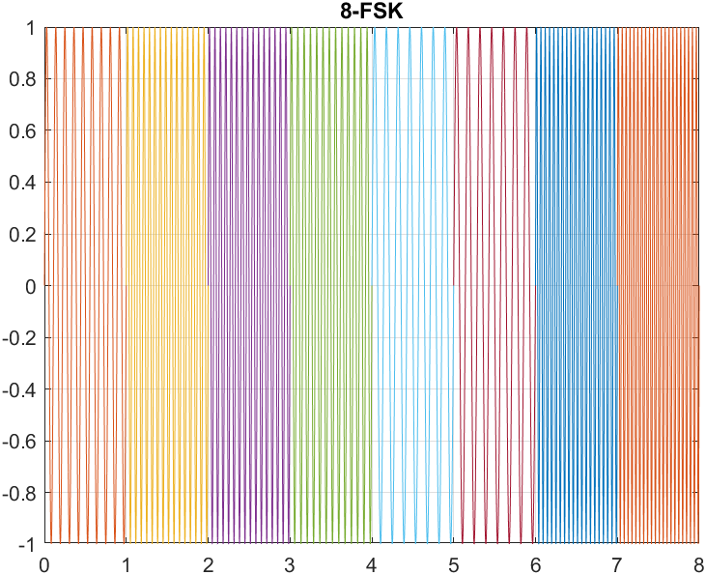

Answer to the question no 3:

x=[0 0 1 1 0 0 1 0 0 0 1 1 0 0 0 0 0 0 1 1 0 1 1 1];

n=length(x);

i=1;

while i<n+1

t=(i-1)/3:0.0001:(i+2)/3;

if (x(i)== 0 && x(i+1) == 0)

psk=1*sin(2*pi*1*t-(6*pi/8));

elseif (x(i)== 0 && x(i+1) == 1)

psk=1*sin(2*pi*1*t+(6*pi/8));

elseif (x(i)== 1 && x(i+1) == 0)

psk=1*sin(2*pi*1*t-(pi/4));

elseif (x(i)== 1 && x(i+1) == 1)

psk=1*sin(2*pi*1*t+(pi/4));

end

plot(t,psk);

hold on;

grid on;

title('Quadrature Phase Shift Key (QPSK)');

i=i+2;

end

